TMA 4100 Skriftlig innlevering 1

1:

C:\2B5C0B45\5FE05728-E304-4B88-BAB8-09810F3446A9_files\image001.png

C:\2B5C0B45\5FE05728-E304-4B88-BAB8-09810F3446A9_files\image002.png

C:\2B5C0B45\5FE05728-E304-4B88-BAB8-09810F3446A9_files\image003.png

C:\2B5C0B45\5FE05728-E304-4B88-BAB8-09810F3446A9_files\image004.png

2:

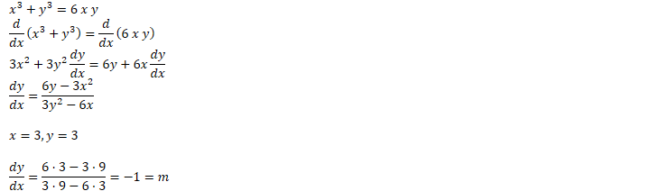



C:\2B5C0B45\5FE05728-E304-4B88-BAB8-09810F3446A9_files\image007.png

3:

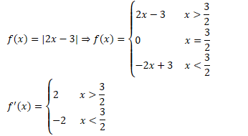

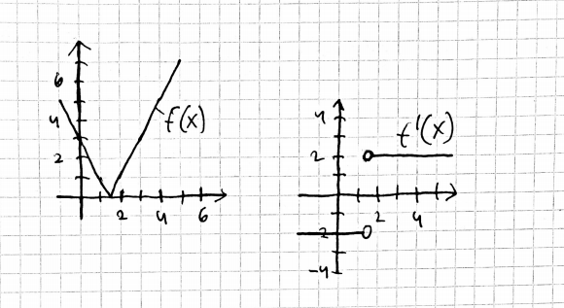

4:

C:\2B5C0B45\5FE05728-E304-4B88-BAB8-09810F3446A9_files\image010.png

C:\2B5C0B45\5FE05728-E304-4B88-BAB8-09810F3446A9_files\image011.png

C:\2B5C0B45\5FE05728-E304-4B88-BAB8-09810F3446A9_files\image012.png

C:\2B5C0B45\5FE05728-E304-4B88-BAB8-09810F3446A9_files\image013.png